**Module 10 – Single Page Application framework – React**

**8.ReactJS-HOL**

**Explain React State.**

In React, state is an object that holds information or data about the component.  
It determines how that component behaves and how it appears on the screen.

State can change over time (unlike props which are read-only).  
When the state of a component changes, React re-renders the component to reflect the new data.

**Structure:**

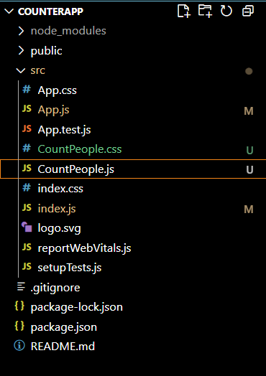

**App.js:**

import React from "react";

import CountPeople from "./CountPeople";

function App() {

  return (

    <div>

      <CountPeople />

    </div>

  );

}

export default App;

**CountPeople.js:**

import React, { Component } from "react";

import "./CountPeople.css";

class CountPeople extends Component {

  constructor() {

    super();

    this.state = {

      entrycount: 0,

      exitcount: 0,

    };

  }

  updateEntry = () => {

    this.setState((prevState) => ({

      entrycount: prevState.entrycount + 1,

    }));

  };

  updateExit = () => {

    this.setState((prevState) => ({

      exitcount: prevState.exitcount + 1,

    }));

  };

  render() {

    return (

      <div className="main">

        <div className="entry-box">

          <button className="btn login" onClick={this.updateEntry}>Login</button>

          <span className="msg">{this.state.entrycount} People Entered!!!</span>

        </div>

        <div className="exit-box">

          <button className="btn exit" onClick={this.updateExit}>Exit</button>

          <span className="msg">{this.state.exitcount} People Left!!!</span>

        </div>

      </div>

    );

  }

}

export default CountPeople;

**CountPeople.css:**

.main {

  text-align: center;

  margin-top: 50px;

  display: flex;

  justify-content: space-evenly;

}

.entry-box, .exit-box {

  display: flex;

  align-items: center;

}

.btn {

  padding: 5px 15px;

  margin-right: 10px;

  border: none;

  font-weight: bold;

  color: white;

  border-radius: 5px;

}

.login {

  background-color: green;

}

.exit {

  background-color: green;

}

.msg {

  font-size: 16px;

  font-weight: normal;

}

**index.js:**

import React from "react";

import ReactDOM from "react-dom/client";

import "./index.css";

import App from "./App";

const root = ReactDOM.createRoot(document.getElementById("root"));

root.render(<App />);

**index.css:**

body {

  margin: 0;

  font-family: -apple-system, BlinkMacSystemFont, 'Segoe UI', 'Roboto', 'Oxygen',

    'Ubuntu', 'Cantarell', 'Fira Sans', 'Droid Sans', 'Helvetica Neue',

    sans-serif;

  -webkit-font-smoothing: antialiased;

  -moz-osx-font-smoothing: grayscale;

}

code {

  font-family: source-code-pro, Menlo, Monaco, Consolas, 'Courier New',

    monospace;

}

**Output:**

